

Assignment 1 Data Visualization

**Nelson da Graça Leite Alamô**

Tutor: Vinita Silaparasetty

February 17, 2023

Contents

Introduction 2

First Task 3

1. Data Protection Policy 3

2. Purpose 3

3. Scope 3

4. The Policy 5

5. Data Protection Risks 6

6. Roles and Responsibilities 6

Second task 8

Excel/Data 8

Charts 10

Macros 12

Third Task 13

Tableau 13

1.Bar Chart 13

2.Bar Chart 13

3.Map 14

4.Bar Chat 14

Dashboards 15

1. Dashboard 15

2. Dashboard 15

3. Dashboard 16

4. Dashboard 16

Conclusion 17

Reference 18

# Introduction

Data visualisation has become an essential business capability to help transform information into insights that can drive meaningful business outcomes and improved experiences. Today, most organizations have accumulated a wealth of data from the different corners of their businesses they are then unable to see how this data can help them make better decision’s, making actions, and results.

# First Task

## Data Protection Policy

The Department of Health and Social Care (DHSC) needs to gather and use certain information about individuals. These can include customers, suppliers, business contacts, employees and other people the organisation has a relationship with or may need to contact. This policy describes how this personal data must be collected, handled and stored to meet the organisation’s data protection standards — and to comply with the law.

## Purpose

The principles underlying this data protection policy ensures DHSC:

* Complies with Data Protection legislation and follows good practice.
* Protects the rights of staff, customers, and partners.
* Is open about how it stores and processes individuals’ data.
* Protects itself from the risks of a data breach or cyber-attack on its systems.

## Scope

3.1 This policy applies to all personal data and special categories of personal data (previously known as sensitive data) processed by DHSC and as defined under the General Data Protection Regulation (GDPR), including structured sets of personal data held in electronic or other filing systems that are accessible according to specified criteria.

3.2 'Personal Data' means any information relating to an identified or identifiable living individual. Identifiable living individual means a living individual who can be identified, directly or indirectly, in particular by reference to: (a) an identifier such as a name, an identification number, location data or an online identifier; or (b) one or more factors specific to the physical, physiological, genetic, mental, economic, cultural, or social identity of the individual.

3.3 This can include:

* names of individuals.
* postal addresses.
* email addresses.
* telephone numbers.
* any other information relating to individuals.

3.4 For personal data to be processed lawfully, one or more of the following legal grounds must apply:

* the data subject has given consent to the processing of his or her personal data for one or more specific purposes.
* processing is necessary for compliance with a legal/statutory obligation to which the controller is subject to.
* processing is necessary in order to protect the vital interests of the data subject or of another natural person.
* processing is necessary for the performance of a task carried out in the public interest or in the exercise of official authority vested in the controller.

Special categories of personal data (sensitive data)

3.5 These are personal data deemed to be more sensitive by law, and so need additional protection. They cannot be processed unless at least one further condition for processing special category data is fulfilled. These conditions are:

* the data subject has given explicit consent.
* the processing is necessary in the context of employment law, or laws relating to social security and social protection.
* the processing is necessary to protect vital interests of the data subject or of another natural person.
* the processing is carried out in the course of the legitimate activities of a charity or not-for-profit body, with respect to its own members, former members, or persons with whom it has regular contact in connection with its purposes.
* the processing relates to personal data which have been manifestly made public by the data subject.
* the processing is necessary for the establishment, exercise, or defence of legal claims, or for courts acting in their judicial capacity.
* the processing is necessary for reasons of substantial public interest, and occurs on the basis of a law that is, inter alia, proportionate to the aim pursued and protects the rights of data subjects.
* the processing is required for the purpose of medical treatment undertaken by health professionals, including assessing the working capacity of employees and the management of health or social care systems and services.

## The Policy

4.1 This policy sets out the Department's commitment to: protecting personal data; how this commitment is implemented with regard to the collection and use of personal data; and ensuring the rights of individuals whose data is held (the Data Subject) can be exercised as prescribed by the General Data Protection Regulation. DHSC is committed to ensuring that it complies with the underpinning six data protection principles, as listed below.

**4.2 The 6 Data Protection principles:**

* personal data shall be processed lawfully, fairly and in a transparent manner in relation to individuals.
* personal data shall be obtained for one or more specified, explicit, and lawful purposes, and shall not be further processed in any manner incompatible with that purpose or those purposes.
* personal data must be adequate, relevant, and limited to what is necessary in relation to the purposes for which they are processed.
* personal data shall be accurate and, where necessary, kept up to date.
* personal data shall be kept in a form which permits identification of data subjects for no longer than is necessary for the purposes for which the personal data are processed.
* personal data shall be processed in a manner that ensures appropriate security of the personal data, including protection against unauthorised or unlawful processing and against accidental loss, destruction, or damage, using appropriate technical or organisational measures.

**4.3 These principles will be adhered to with the following ambitions:**

* meeting our legal obligations as laid down by the GDPR.
* ensuring that data is collected and used fairly, lawfully, and transparently (excepting the provisions of the Law Enforcement Directive).
* processing personal data where an appropriate legal basis to do so exists and only in order to meet our operational needs or fulfil legal requirements.
* taking steps to ensure that personal data is up to date and accurate.
* establishing appropriate retention periods for personal data.
* ensuring that data subjects' rights can be appropriately exercised.
* ensuring that a nominated officer is responsible for data protection compliance and provides a point of contact for all data protection issues, i.e., Data Protection Officer.
* ensuring that all staff are made aware of good practice in data protection.
* providing adequate training for all staff responsible for personal data.
* ensuring that everyone handling personal data knows where to find further guidance.
* ensuring that queries about data protection, internal and external to the organisation, are dealt with effectively and promptly.
* sharing information where required by law and where approved information sharing agreements are in place and when agreed processes have been followed.
* regularly reviewing data protection procedures and guidelines within the organisation.
* adopting local and national data protection best practice, including incorporation of appropriate learning from any published ICO data protection and/or European Data Protection Board (EDPB) guidance.
* publishing and promoting this policy and the rights of data subjects including how to make a right of access request.
* registering with the Information Commissioner as an organisation which handles data.
* establishing procedures for reporting data protection breaches to relevant authorities for investigation, including self-referral mechanisms.
* being clear with individuals whose data we process as to how we store it, what we do with it and why.
* responding to any valid subject access requests promptly and in any event within one month of receiving them (unless limited exceptions apply).

## Data Protection Risks

5.1 This policy helps to protect DHSC from some very real data security risks, including:

* breach of confidentiality and public trust; for instance, information being shared inappropriately.
* failing to offer choice; for instance, all individuals should be free to choose how the organisation uses data relating to them when the processing is by consent.
* failing to observe the enhanced rights that citizens have under the GDPR - for example, right of access, right to rectification, etc.
* reputational damage, for instance, the Department could suffer if hackers were to successfully corrupt, gain access to or steal sensitive data.

## Roles and Responsibilities

6.1 DHSC's responsibilities:

* DHSC is the data controller under Data Protection Legislation for the personal data it processes for its own purposes. It is also a joint data controller for business undertaken through its Executive Agencies - the Medicines and Healthcare Products Regulatory Agency and Public Health England.
* the Accounting Officer has overall responsibilities for compliance with data Protection legislation.
* • the DHSC Data Protection Officer (DPO) is responsible for monitoring progress and advising the organisation on implementation of this policy; acting as primary contact on any data protection queries; and approving responses to Right of Access requests (generally described in this document as 'Subject Access Requests').
* the DPO is also responsible for monitoring the completion of all mandatory training for all staff (with special emphasis on staff handling personal data on daily basis) and to ensure access to further guidance and support.
* the DPO will monitor and report on all data processor requirements e.g. Roles & Responsibilities, notification, data subject access requests;
* the DPO is the first point of contact for the regulatory authorities and for individuals whose data is processed (employees, customers etc.)

**Employee responsibilities**

6.2 All employees have individual responsibility for complying with this policy and following accompanying guidance.

6.3 All employees will undertake relevant data protection training, including the Civil Service Learning ‘Responsible for Information’ training, and any other training that shall be deemed as mandatory.

6.4 Employees will:

* observe all forms of guidance, codes of practice and procedures about the collection, sharing, handling and use of personal information.
* develop a comprehensive understanding of the purpose for which DHSC uses personal information.
* collect and process information in accordance with the purpose for which it is required to be used by DHSC to meet its statutory requirements and business needs.
* ensure the information is destroyed when no longer required in line with our information management guidance.

# Second task

## Excel/Data

1. Set a password to protect the workbook.
2. Highlight column C and change the data to display in British Pound symbol.

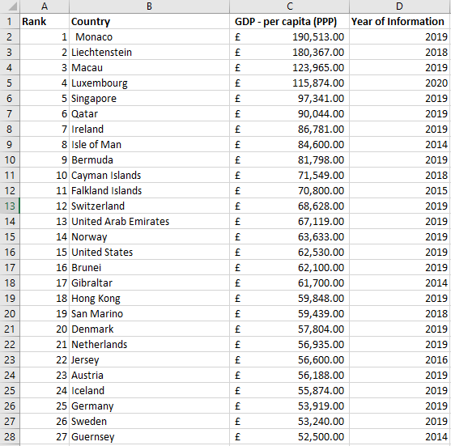

1. Turn the GDP sheet into a table.

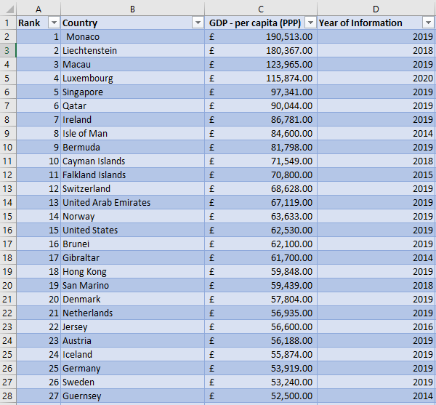

1. Filter the table to display only the information for 2019.

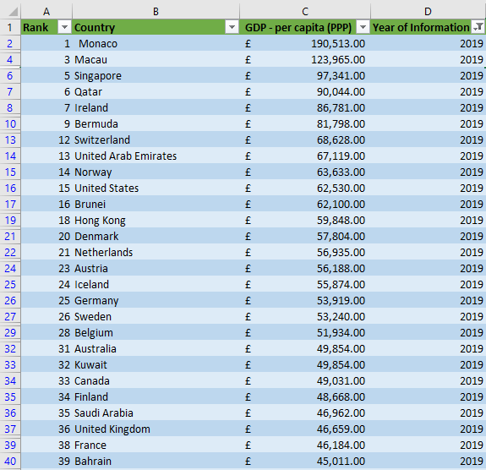

## Charts

1. Next create a chart that will only display the following data ‘Rank, Country, and GDP - per capita (PPP). The chart can be anything as long as it is suitable.

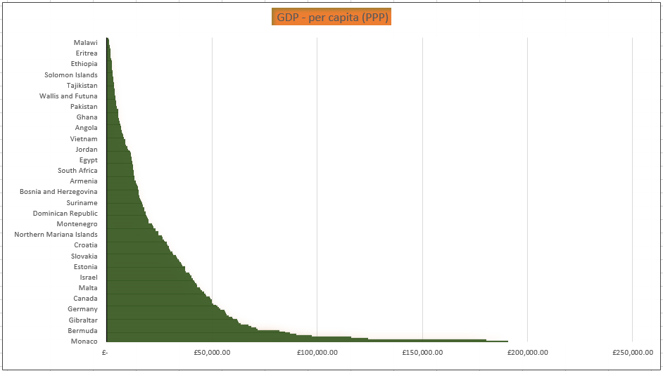

1. Using your creative skills edit the chart a. Add a title.

b. Add X and Y axis labels.

c. Make the chart visually pleasing.

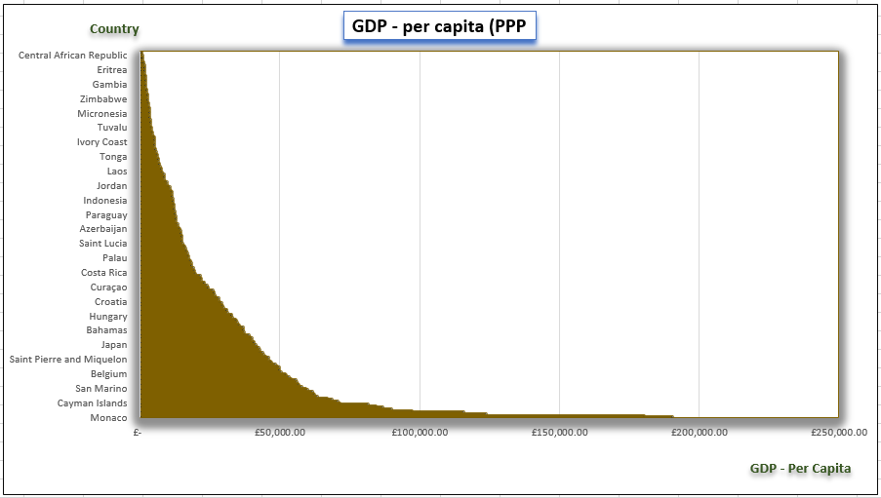

1. Move the chart to a new sheet tab and label with a suitable name.
2. Create a sort for the top 20 highest ranking counties.
3. Next create a new Bar chart to display the 20 highest ranking countries from your sort and then move the chart to be underneath the table, as shown below.

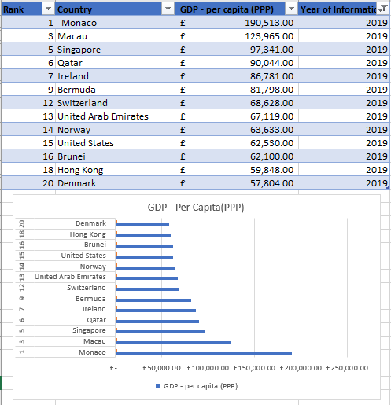

1. Colour the background by highlighting the area underneath the table as shown below. Find the add a fill colour icon and select a colour.

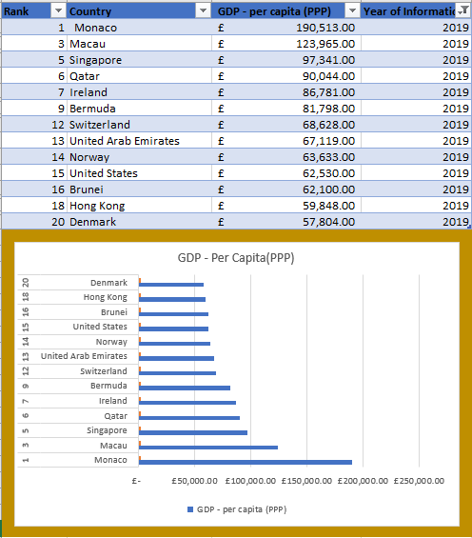

## Macros

1. The next task is to create 3 macro buttons, print the sheet, Save the file, and copy the sheet.

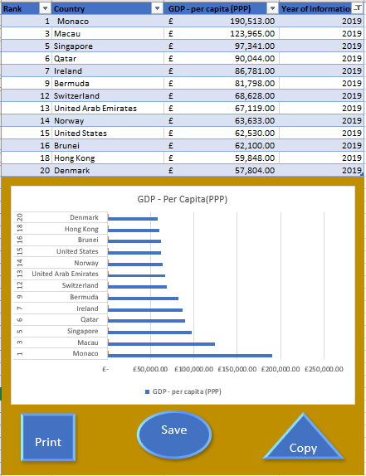

# Third Task

## Tableau

### 1.Bar Chart

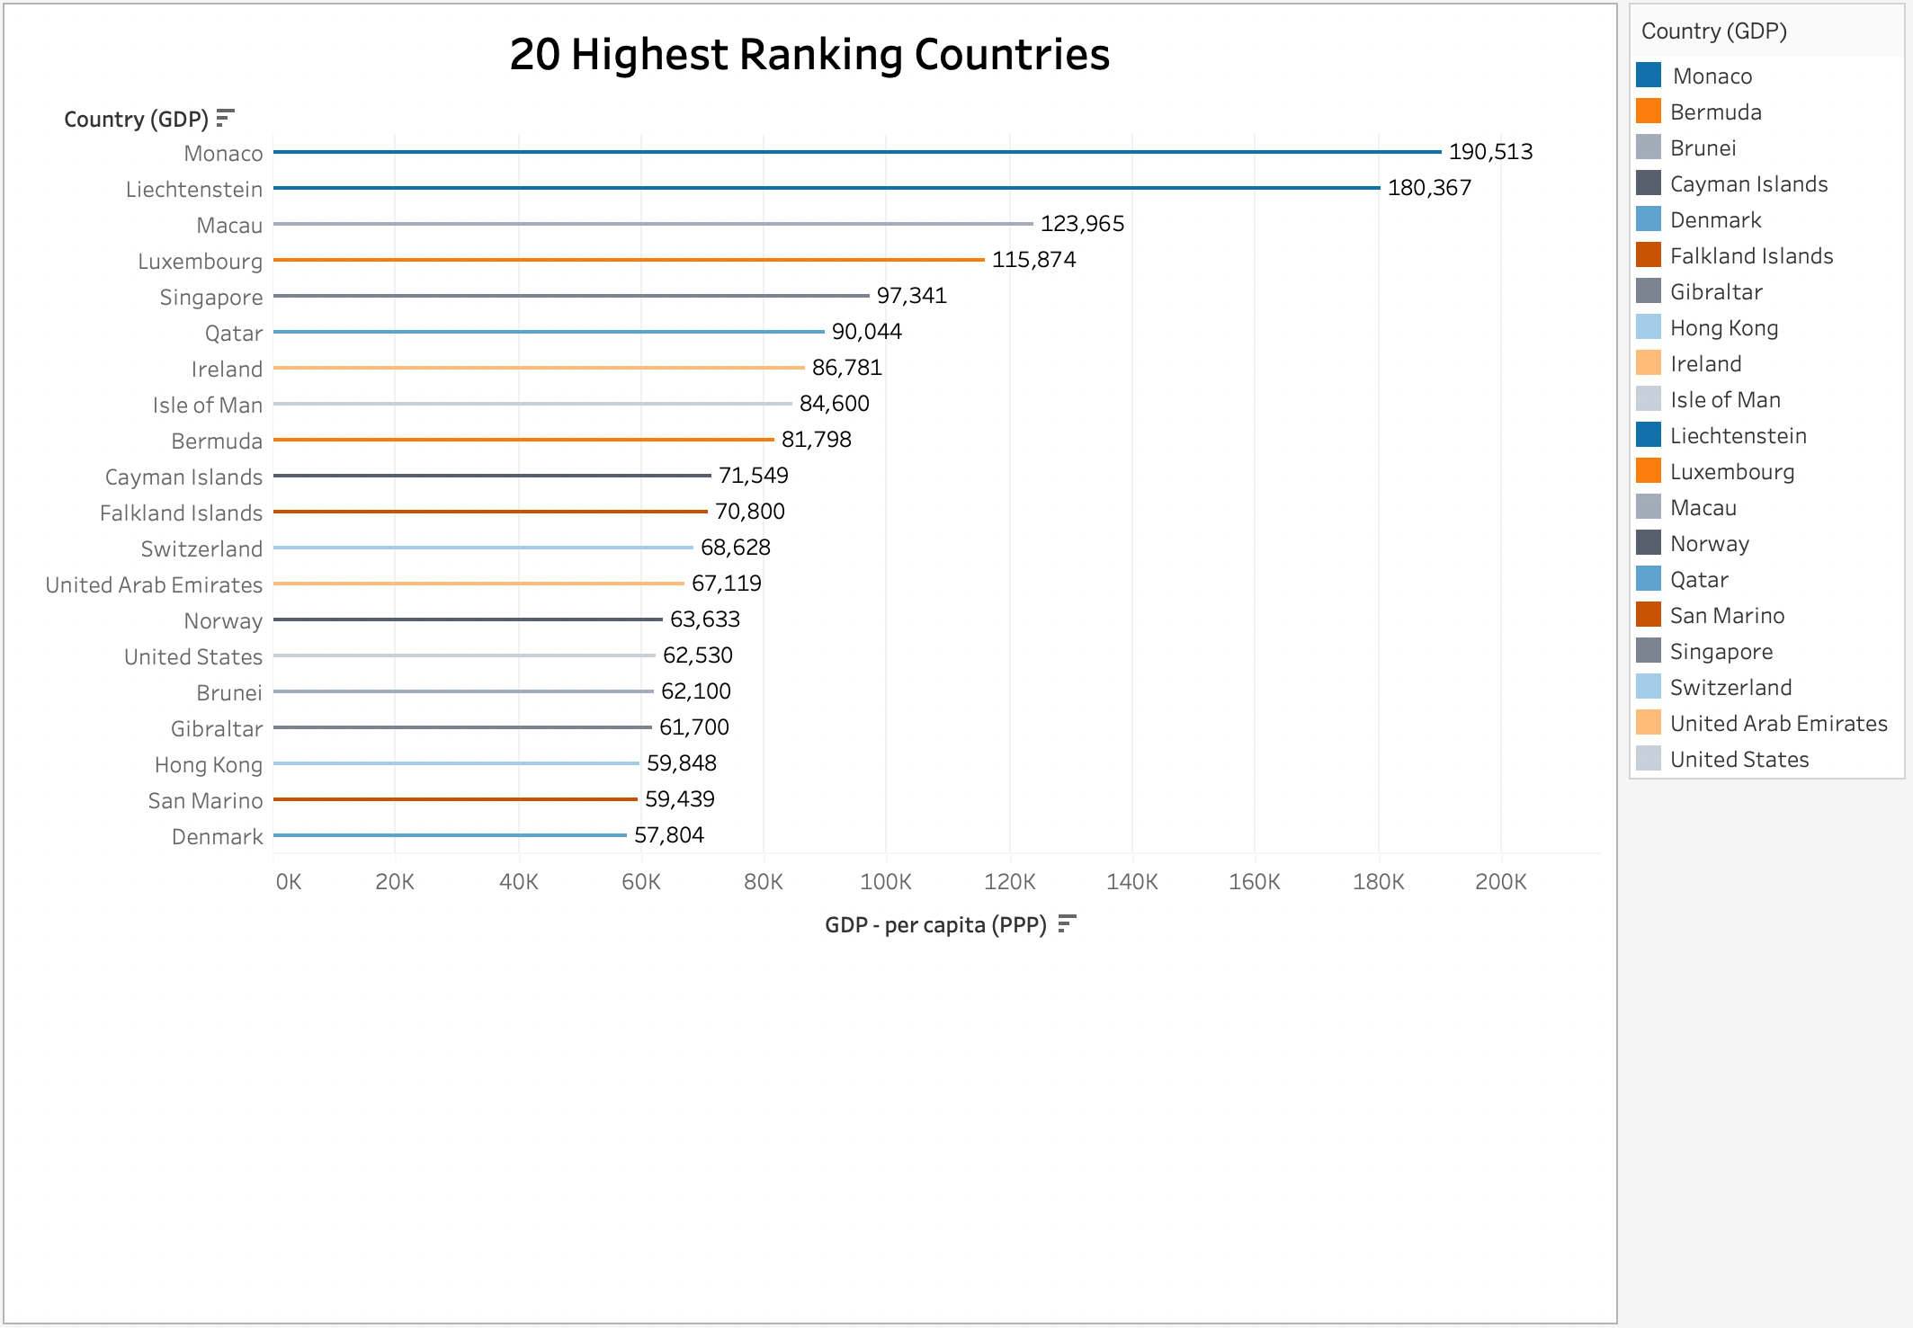

### 2.Bar Chart

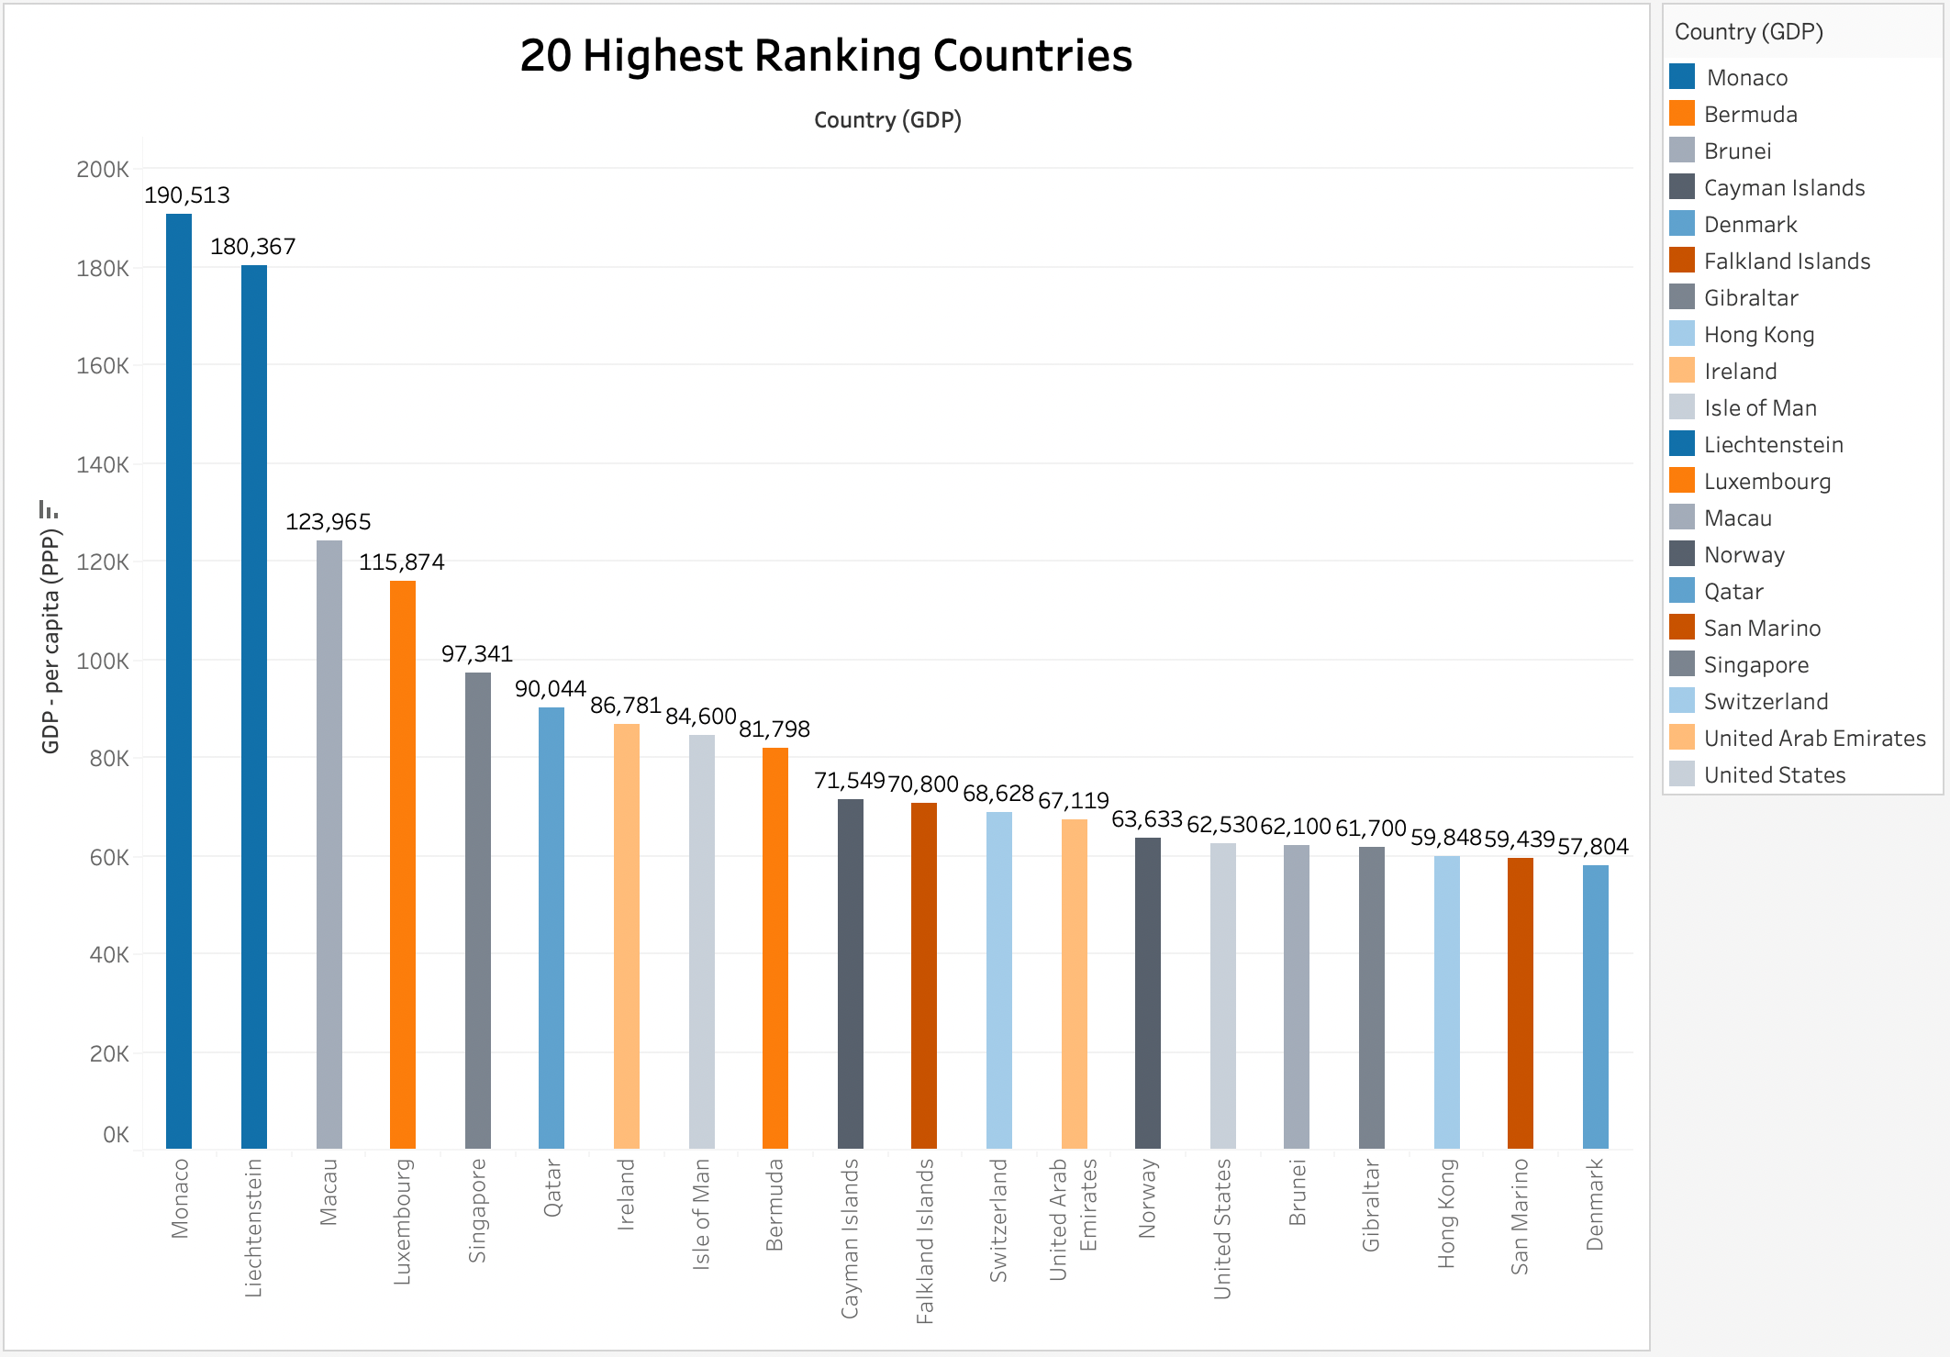

### 3.Map

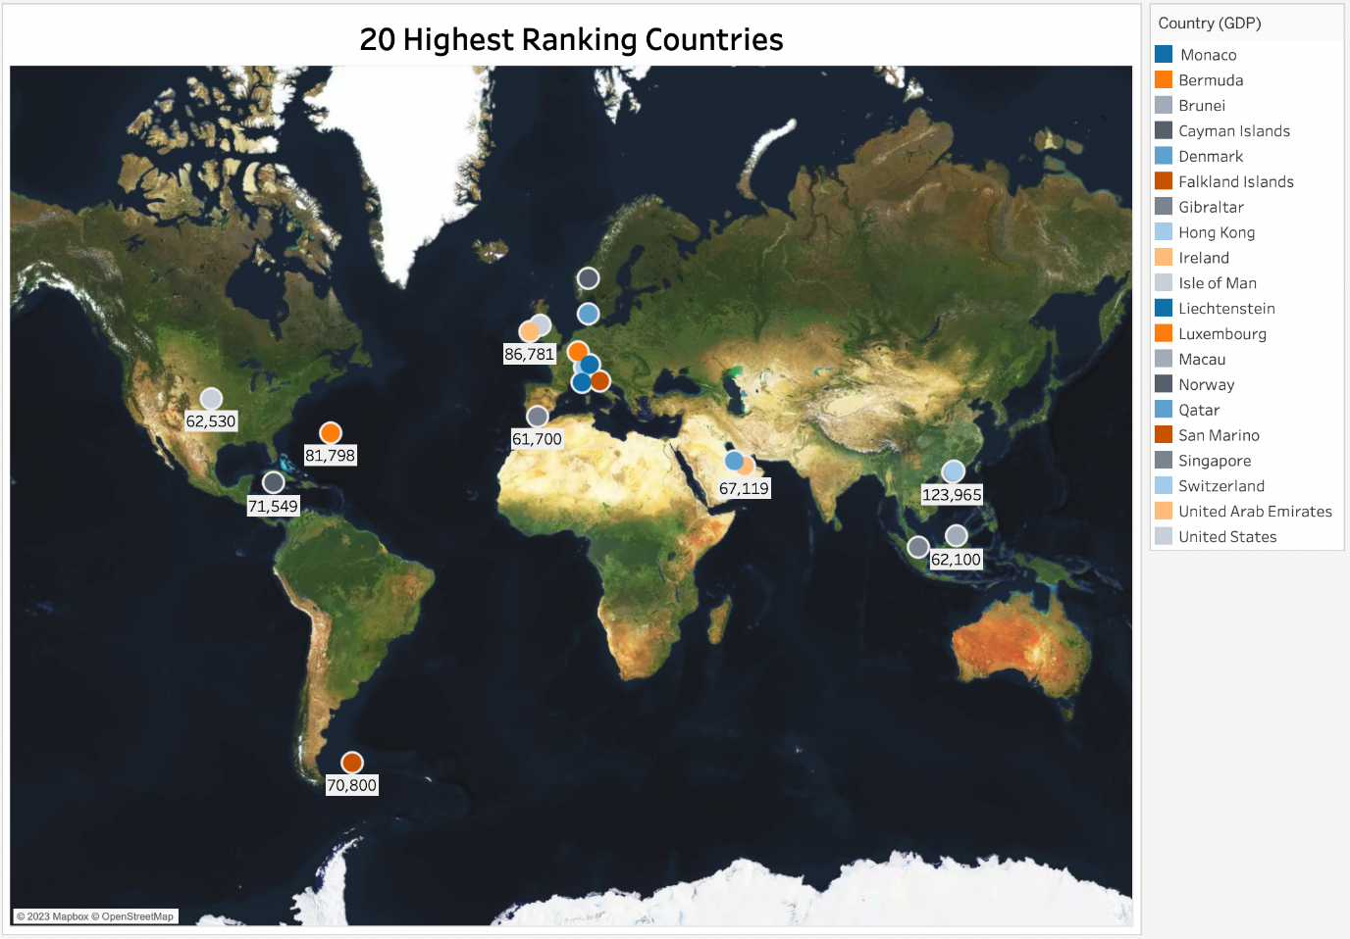

### 4.Bar Chat

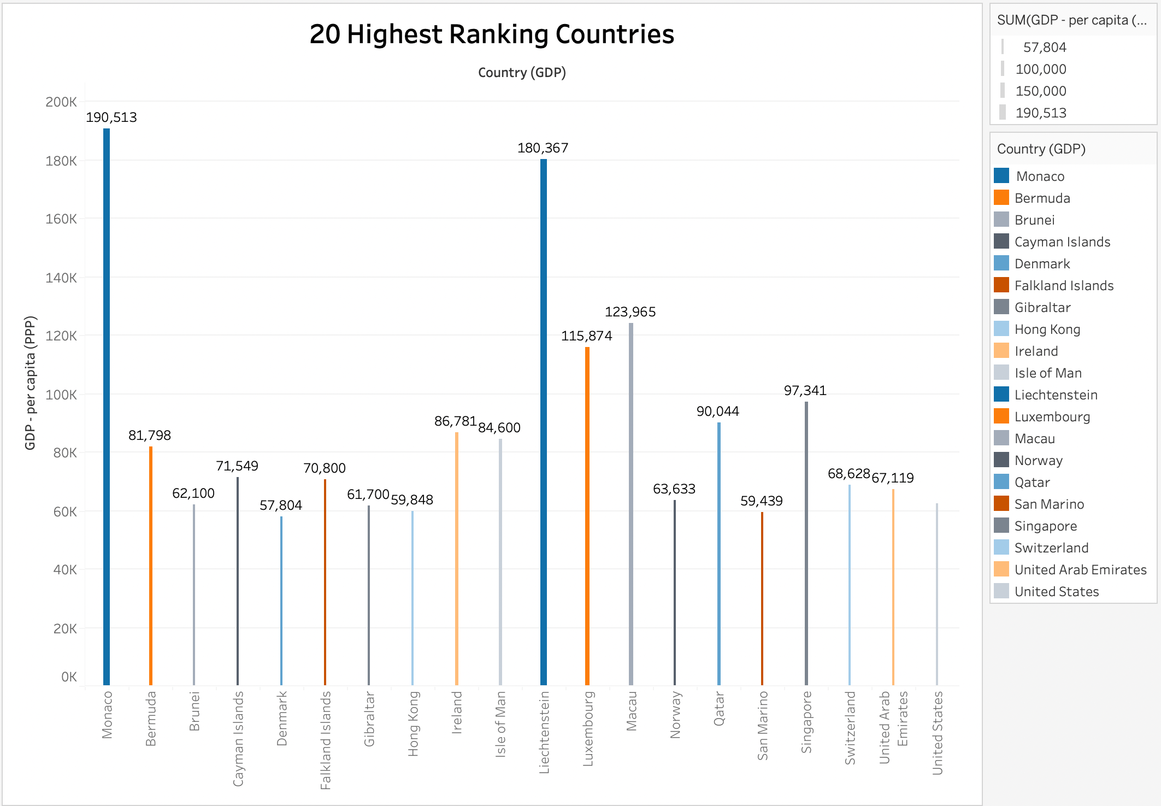

## Dashboards

### 1. Dashboard

### 2. Dashboard

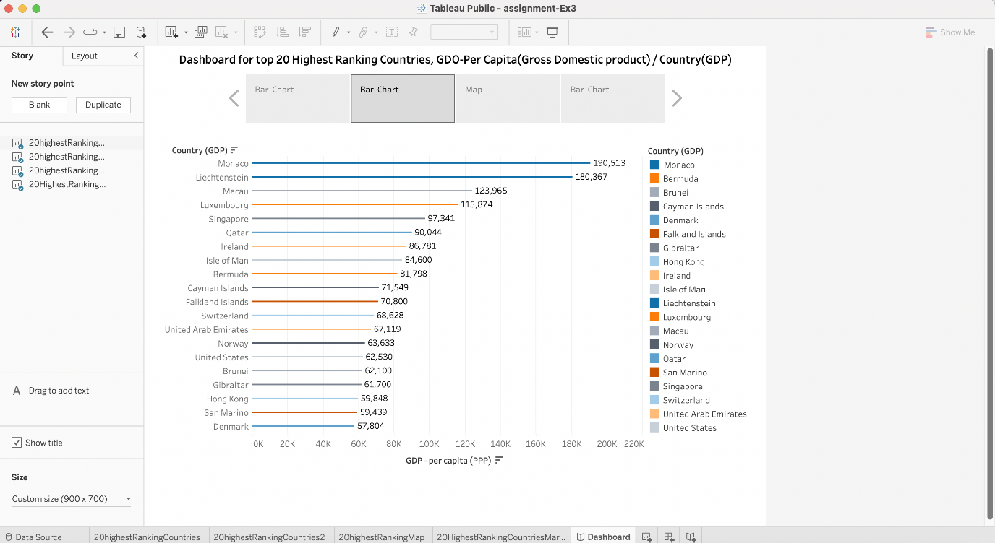

### 3. Dashboard

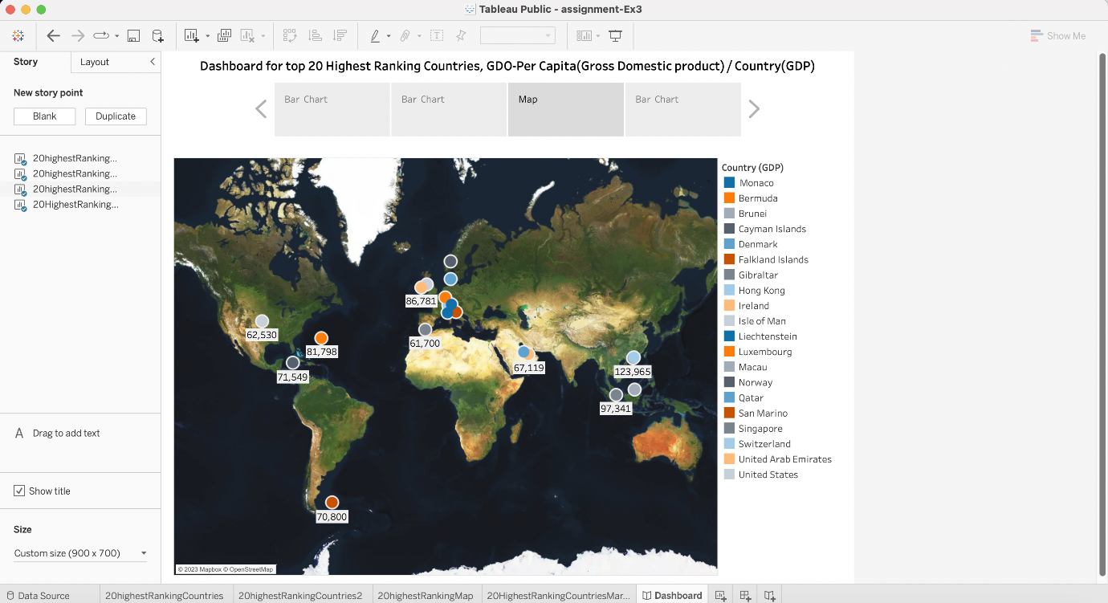

### 4. Dashboard

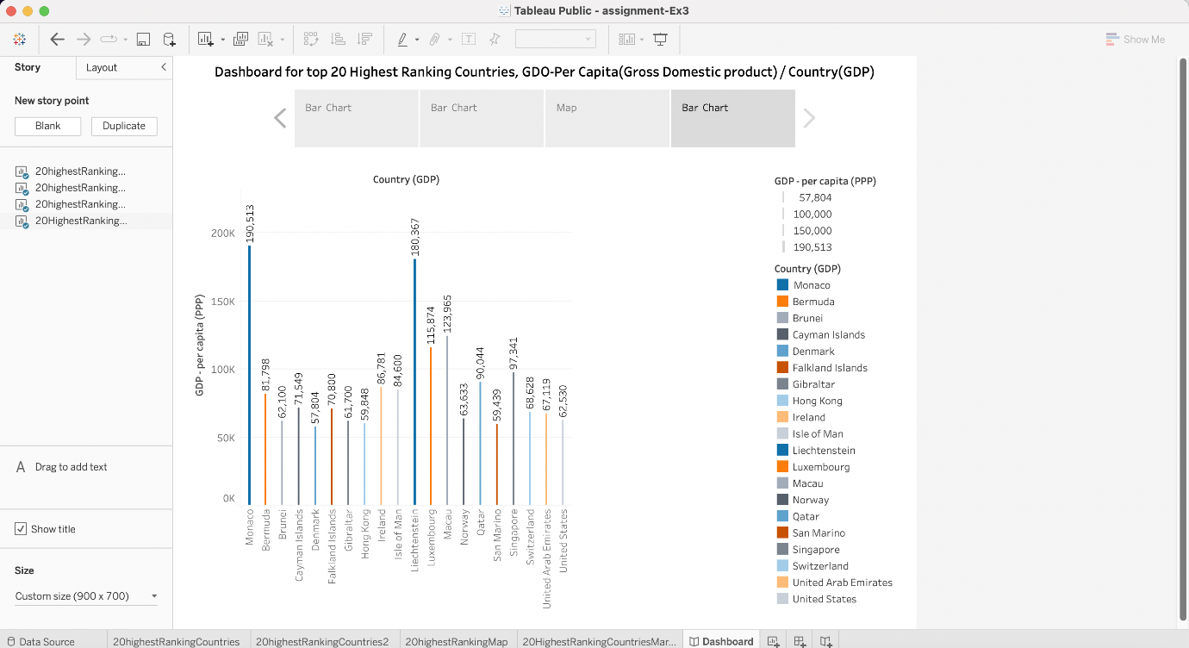

# Conclusion

Data visualization is one of the most powerful mechanisms to exploit and analyse autonomously the implied meaning in the data, regardless of the degree of technological knowledge of the user. Visualization allows us to construct meaning from the data and create narratives based on the graphical representation.

# Reference

<https://assets.publishing.service.gov.uk/government/uploads/system/uploads/attachment_data/file/925300/data-protection-policy.pdf>

<https://public.tableau.com/app/profile/nelson3559/viz/assignment-Ex3/Story1?publish=yes>

<https://www.justit.co.uk/>